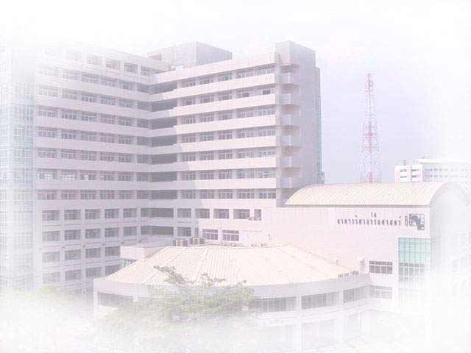
International Graduate Program in Civil Engineering
( IPCE )
Department of Civil Engineering, Faculty of Engineering, Kasetsart University
Major:

1. Structural Engineering (ST)
2. Construction Engineering and Management (CM)

Second Semester 2006 Admission

- Academic Program 2 years (4 semesters) per course
- Academic Staff Department of Civil Engineering, KU
Tokyo Institute of Technology
Kumamoto University
Griffith University
- Class Schedule Monday – Friday 5.00 p.m. – 8.00 p.m.
Saturday 9.00 a.m. – 4.00 p.m.
- Qualifications Pass requirements 1 and 2
1. Pass requirements 1.1 or 1.2
1.1 Bachelor Degree in Civil Engineering
or related filed with GPA of 2.5 or above
1.2 GPA of less than 2.5 but with a minimum of
3 years working experience
2. English Test of IPCE or 500 TOEFL scores
- Expenditure About 65,000 baht per semester or 260,000 Baht
per program
- Application Form Available at the web site and office all year round

- Application Now – October 16, 2006

- Start of Semester October 30, 2006

- Location Room 8505, Building 8, Faculty of Engineering,
Kasetsart University
- Inquiry Tel. 02-942-8555 ext. 1333
Tel./Fax 02-579-3171
civilinter@ku.ac.th
- Website http://civilinter.eng.ku.ac.th

SECOND SEMESTER, 2006

ADMISSION CALENDAR

SCHEDULES | DATE
- Application Form Download  http://civilinter.eng.ku.ac.th | Now – October 16, 2006
- Submission of Application Form | Now – October 16, 2006
 | Mon – Fri  Sat | - 09.00 AM.–07.00 PM.  - 09.00 AM.–12.00 NOON
- Interview (English) | October 20, 2006 | - 09.00 AM.–12.00 NOON
- Announcement of Successful Applicants | October 24, 2006
- Report and Receive Documents  for Registration | October 30 – 31, 2006
- Orientation for New Students | October 30, 2006
- Enrolment and Payment of Tuition Fee | October 30, 2006
- Start of Semester | October 30, 2006
- English Examination | October 14, 2006 | - 09.00 AM.–12.00 NOON

